CITES AT Myths and Facts: ALT text for graphics
Important: Please use this document when adding Alt Text to your Myths & Facts Graphics.
- AT Costs and Funding
- AT Devices and Services
- AT Requirements Under IDEA (Part B)
- AT Requirements Under IDEA (Part C)
- Deploying AT Devices and Services

AT Costs and Funding
Myth/Fact number | File name and link | Thumbnail | ALT text
27 | CITES-MythVSFact-CostComparison-square.png | 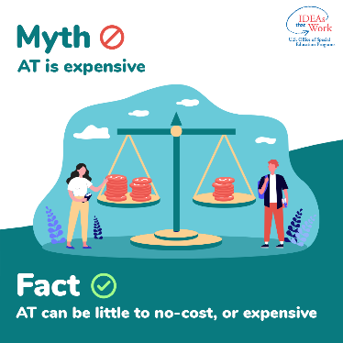 | Square graphic. Myth: AT is expensive. Fact: AT can be little to no-cost, or expensive.
27 | CITES-MythVSFact-CostComparison-wide.png | 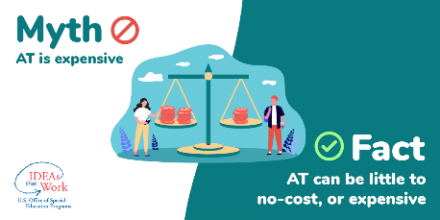 | Wide rectangular graphic. Myth: AT is expensive. Fact: AT can be little to no-cost, or expensive.

AT Devices and Services
Myth/Fact number | File name and link | Thumbnail | ALT text
9 | CITES-MythVSFact-ATHighTech-square.png | 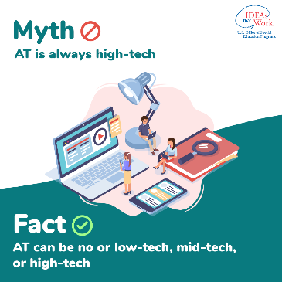 | Square graphic. Myth: AT is always high-tech. Fact: AT can be no or low-tech, mid-tech, or high-tech.
9 | CITES-MythVSFact-ATHighTech-wide.png | 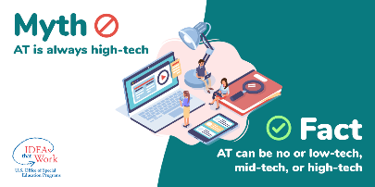 | Wide rectangular graphic. Myth: AT is always high-tech. Fact: AT can be no or low-tech, mid-tech, or high-tech.
10 | CITES-MythVSFact-ATForAllChildren-square.png | 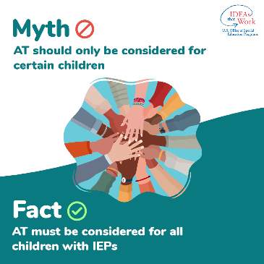 | Square graphic. Myth: AT should only be considered for certain children. Fact: AT must be considered for all children with IEPs.
10 | CITES-MythVSFact-ATForAllChildren-wide.png | 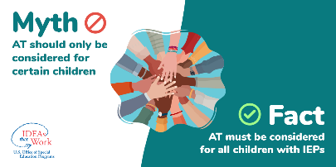 | Wide rectangular graphic. Myth: AT should only be considered for certain children. Fact: AT must be considered for all children with IEPs.
11 | CITES-MythVSFact-247-square.png | 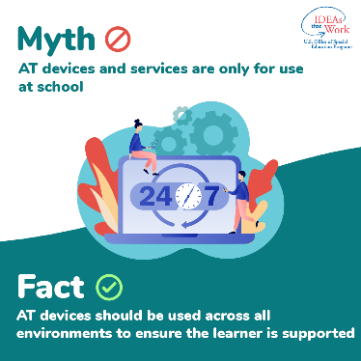 | Square graphic. Myth: AT devices and services are only for use at school. Fact: AT devices should be used across all environments to ensure the learner is supported.
11 | CITES-MythVSFact-247-wide.png | 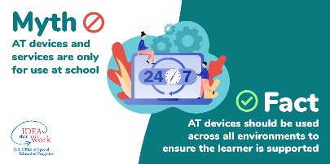 | Wide rectangular graphic. Myth: AT devices and services are only for use at school. Fact: AT devices should be used across all environments to ensure the learner is supported.
12 | CITES-MythVSFact-SpecificNeeds-square.png | 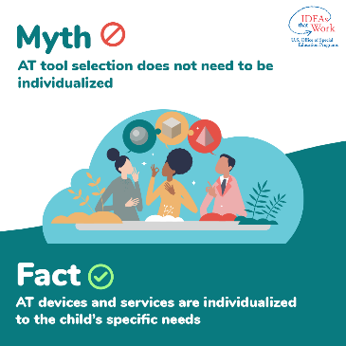 | Square graphic. Myth: AT tool selection does not need to be individualized. Fact: AT devices and services are individualized to the child’s specific needs.
12 | CITES-MythVSFact-SpecificNeeds-wide.png | 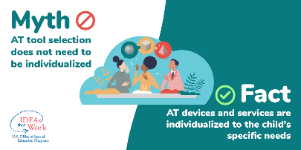 | Wide rectangular graphic. Myth: AT tool selection does not need to be individualized. Fact: AT devices and services are individualized to the child’s specific needs.
13 | CITES-MythVSFact-IndiviualLearner-square.png | 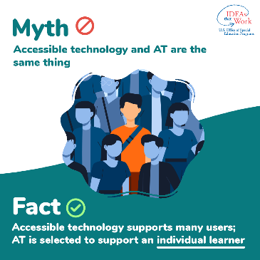 | Square graphic. Myth: Accessible technology and AT are the same thing. Fact: Accessible technology supports many users; AT is selected to support an individual learner.
13 | CITES-MythVSFact-IndividualLearner-wide.png | 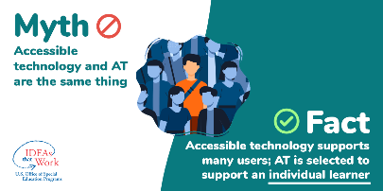 | Wide rectangular graphic. Myth: Accessible technology and AT are the same thing. Fact: Accessible technology supports many users; AT is selected to support an individual learner.
15 | CITES-MythVSFact-ATimprovement-square.png | 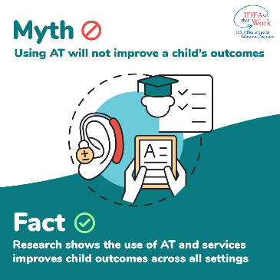 | Square graphic. Myth: Using AT will not improve a child’s outcomes. Fact: Research shows the use of AT and services improves child outcomes across all settings.
15 | CITES-MythVSFact-ATimprovement-wide.png | 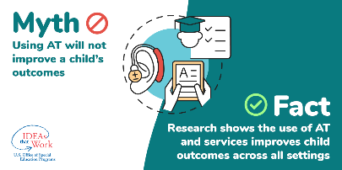 | Wide rectangular graphic. Myth: Using AT will not improve a child’s outcomes. Fact: Research shows the use of AT and services improves child outcomes across all settings.
16 | CITES-MythVSFact-Motivation-square.png | 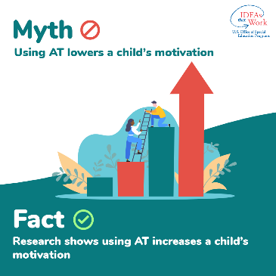 | Square graphic. Myth: Using AT lowers a child’s motivation. Fact: Research shows using AT increases a child’s motivation.
16 | CITES-MythVSFact-Motivation-wide.png | 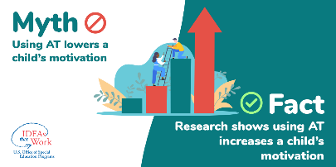 | Wide rectangular graphic. Myth: Using AT lowers a child’s motivation. Fact: Research shows using AT increases a child’s motivation.
17 | CITES-MythVSFact-ATBarrier-square.png | 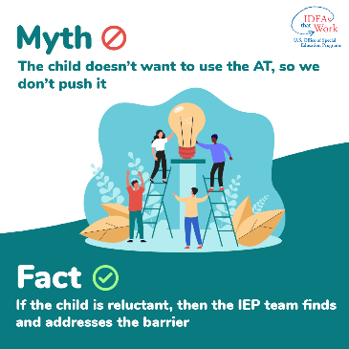 | Square graphic. Myth: The child doesn’t want to use the AT, so we don’t push it. Fact: If the child is reluctant, then the IEP team finds and addresses the barrier.
17 | CITES-MythVSFact-ATBarrier-wide.png | 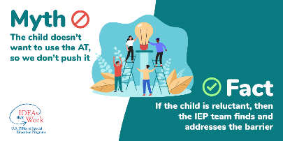 | Wide rectangular graphic. Myth: The child doesn’t want to use the AT, so we don’t push it. Fact: If the child is reluctant, then the IEP team finds and addresses the barrier.
18 | CITES-MythVSFact-ATResponsibility-square.png | 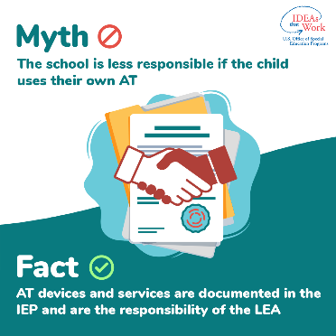 | Square graphic. Myth: The school is less responsible if the child uses their own AT. Fact: AT devices and services are documented in the IEP and are the responsibility of the LEA.
18 | CITES-MythVSFact-ATResponsibility-wide.png | 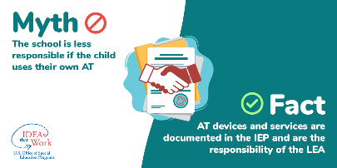 | Wide rectangular graphic. Myth: The school is less responsible if the child uses their own AT. Fact: AT devices and services are documented in the IEP and are the responsibility of the LEA.

AT Requirements Under IDEA (Part B)
Myth/Fact number | File name and link | Thumbnail | ALT text
1 | CITES-MythVSFact-ATinIEPmeetings-square.png | 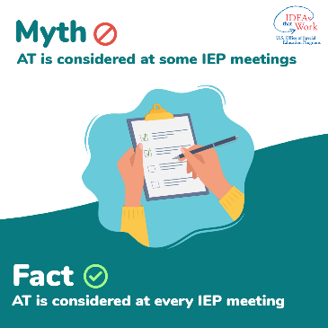 | Square graphic. Myth: AT is considered at some IEP meetings. Fact: AT is considered at every IEP meeting.
1 | CITES-MythVSFact-ATinIEPmeetings-wide.png | 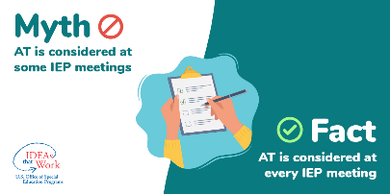 | Wide rectangular graphic. Myth: AT is considered at some IEP meetings. Fact: AT is considered at every IEP meeting.
2 | CITES-MythVSFact-ATDevices-square.png | 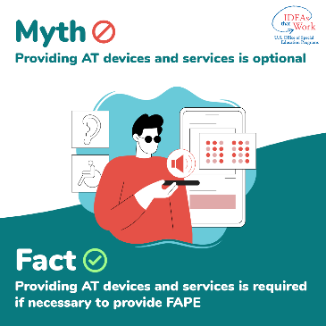 | Square graphic. Myth: Providing AT devices and services is optional. Fact: Providing AT devices and services is required if necessary to provide FAPE.
2 | CITES-MythVSFact-ATDevices-wide.png | 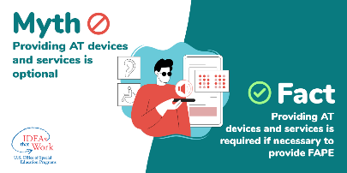 | Wide rectangular graphic. Myth: Providing AT devices and services is optional. Fact: Providing AT devices and services is required if necessary to provide FAPE.
3 | CITES-MythVSFact-IDEArequirements-square.png | 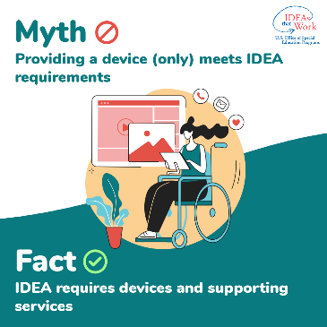 | Square graphic. Myth: Providing a device (only) meets IDEA requirements. Fact: IDEA requires devices and supporting services.
3 | CITES-MythVSFact-IDEArequirements-wide.png | 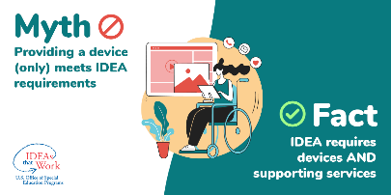 | Wide rectangular graphic. Myth: Providing a device (only) meets IDEA requirements. Fact: IDEA requires devices and supporting services.
4 | CITES-MythVSFact-ATEvaluation-square.png | 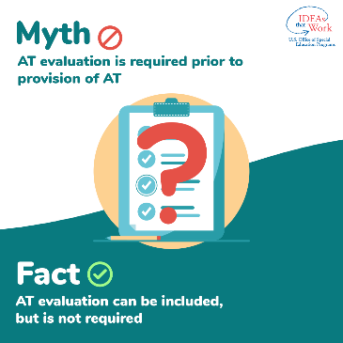 | Square graphic. Myth: AT evaluation is required prior to provision of AT. Fact: AT evaluation can be included but is not required.
4 | CITES-MythVSFact-ATEvaluation-wide.png | 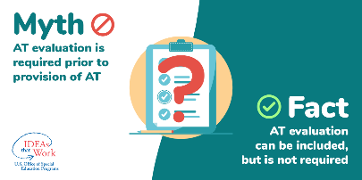 | Wide rectangular graphic. Myth: AT evaluation is required prior to provision of AT. Fact: AT evaluation can be included but is not required.
5 | CITES-MythVSFact-DistrictTraining-square.png | 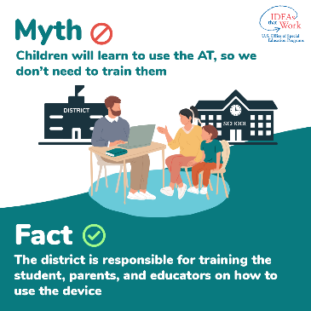 | Square graphic. Myth: Children will learn to use the AT, so we don’t need to train them. Fact: The district is responsible for training the student, parents, and educators on how to use the device.
5 | CITES-MythVSFact-DistrictTraining-wide.png | 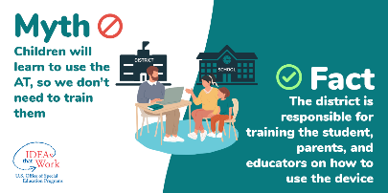 | Wide rectangular graphic. Myth: Children will learn to use the AT, so we don’t need to train them. Fact: The district is responsible for training the student, parents, and educators on how to use the device.
6 | CITES-MythVSFact-ATDocumentation-square.png | 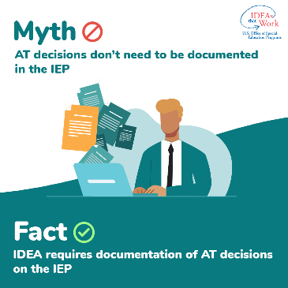 | Square graphic. Myth: AT decisions don’t need to be documented in IEP. Fact: IDEA requires documentation of AT decisions on the IEP.
6 | CITES-MythVSFact-ATDocumentation-wide.png | 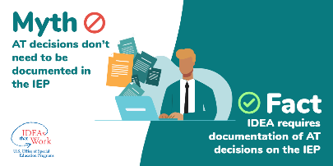 | Wide rectangular graphic. Myth: AT decisions don’t need to be documented in IEP. Fact: IDEA requires documentation of AT decisions on the IEP.
7 | CITES-MythVSFact-TransitionPlan-square.png | 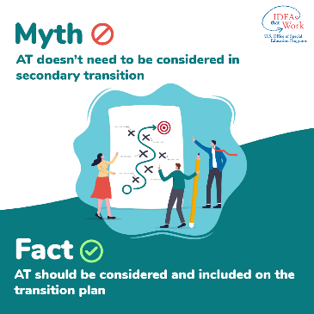 | Square graphic. Myth: AT doesn’t need to be considered in secondary transition. Fact: AT should be considered and included on the transition plan.
7 | CITES-MythVSFact-TransitionPlan-wide.png | 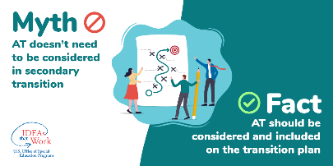 | Wide rectangular graphic. Myth: AT doesn’t need to be considered in secondary transition. Fact: AT should be considered and included on the transition plan.
8 | CITES-MythVSFact-StateAssessments-square.png | 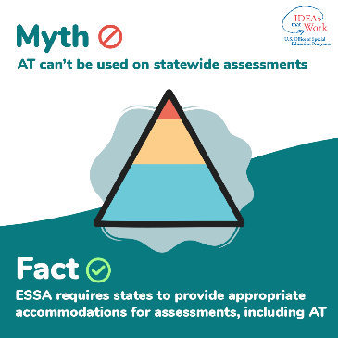 | Square graphic. Myth: AT can’t be used on statewide assessments. Fact: ESSA requires states to provide appropriate accommodations for assessments, including AT.
8 | CITES-MythVSFact-StateAssessments-wide.png | 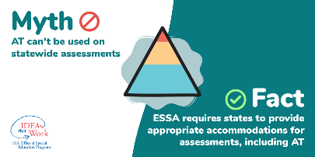 | Wide rectangular graphic. Myth: AT can’t be used on statewide assessments. Fact: ESSA requires states to provide appropriate accommodations for assessments, including AT.

AT Requirements Under IDEA (Part C)
Myth/Fact number | File name and link | Thumbnail | ALT text
23 | CITES-MythVSFact-ChildrenSupport-square.png | 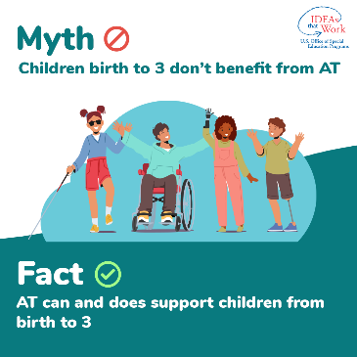 | Square graphic. Myth: Children birth to 3 don’t benefit from AT. Fact: AT can and does support children from birth to 3.
23 | CITES-MythVSFact-ChildrenSupport-wide.png | 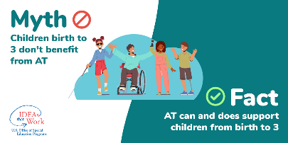 | Wide rectangular graphic. Myth: Children birth to 3 don’t benefit from AT. Fact: AT can and does support children from birth to 3.
24 | CITES-MythVSFact-EarlyIntervention-square.png | 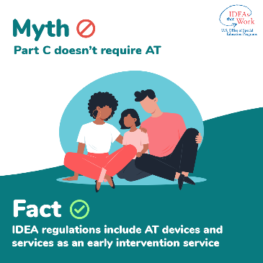 | Square graphic. Myth: Part C doesn’t require AT. Fact: IDEA regulations include AT devices and services as an early intervention service.
24 | CITES-MythVSFact-EarlyIntervention-wide.png | 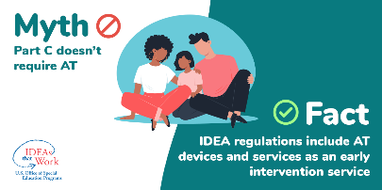 | Wide rectangular graphic. Myth: Part C doesn’t require AT. Fact: IDEA regulations include AT devices and services as an early intervention service.
25 | CITES-MythVSFact-Preschool-square.png | 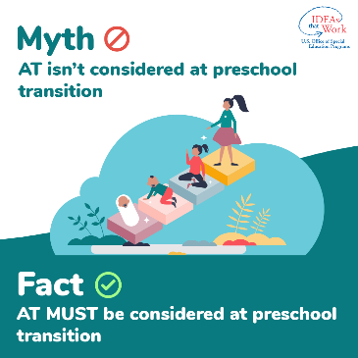 | Square graphic. Myth: AT isn’t considered at preschool transition. Fact: AT must be considered at preschool transition.
25 | CITES-MythVSFact-Preschool-wide.png | 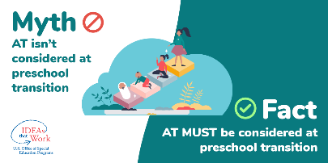 | Wide rectangular graphic. Myth: AT isn’t considered at preschool transition. Fact: AT must be considered at preschool transition.
26 | CITES-MythVSFact-AnyAgeAT-square.png | 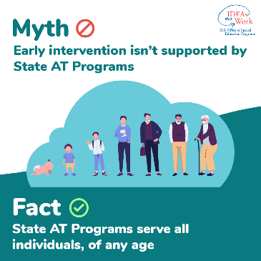 | Square graphic. Early intervention isn’t supported by State AT Programs. Fact: State AT Programs serve all individuals, of any age.
26 | CITES-MythVSFact-AnyAgeAT-wide.png | 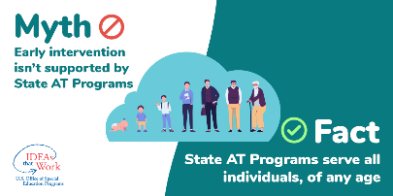 | Wide rectangular graphic. Early intervention isn’t supported by State AT Programs. Fact: State AT Programs serve all individuals, of any age.

Deploying AT Devices and Services
Myth/Fact number | File name and link | Thumbnail | ALT text
19 | CITES-MythVSFact-ATAvailability-square.png | 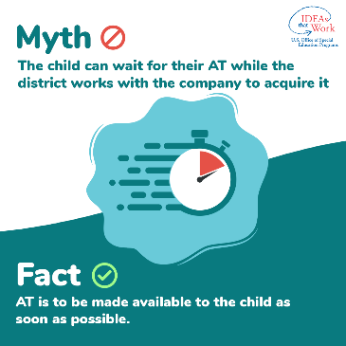 | Square graphic. Myth: The child can wait for their AT while the district works with the company to acquire it. Fact: AT is to be made available to the child as soon as possible.
19 | CITES-MythVSFact-ATAvailability-wide.png | 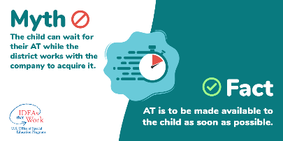 | Wide rectangular graphic. Myth: The child can wait for their AT while the district works with the company to acquire it. Fact: AT is to be made available to the child as soon as possible.
20 | CITES-MythVSFact-IEPapprovesAT-square.png | 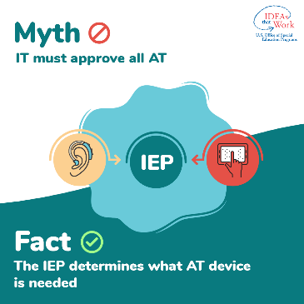 | Square graphic. Myth: IT must approve all AT. Fact: The IEP determines what AT device is needed.
20 | CITES-MythVSFact-IEPapprovesAT-wide.png | 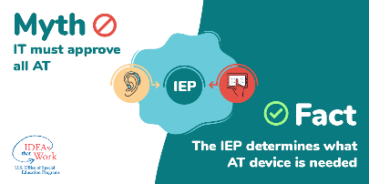 | Wide rectangular graphic. Myth: IT must approve all AT. Fact: The IEP determines what AT device is needed.
21 | CITES-MythVSFact-IDEAqualifiedIndividual-square.png | 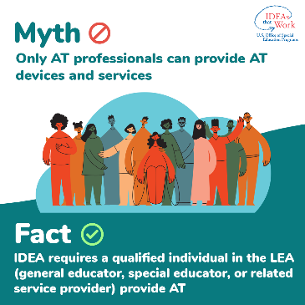 | Square graphic. Myth: Only AT professionals can provide AT devices and services. Fact: IDEA requires a qualified individual in the LEA (general educator, special educator, or related service provider) provide AT.
21 | CITES-MythVSFact-IDEAqualifiedIndividual-wide.png | 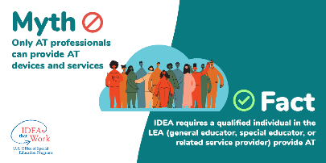 | Wide rectangular graphic. Myth: Only AT professionals can provide AT devices and services. Fact: IDEA requires a qualified individual in the LEA (general educator, special educator, or related service provider) provide AT.
22 | CITES-MythVSFact-ATState-square.png | 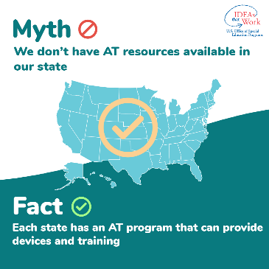 | Square graphic. Myth: We don’t have AT resources available in our state. Fact: Each state has an AT program that can provide devices and training.
22 | CITES-MythVSFact-ATState-wide.png | 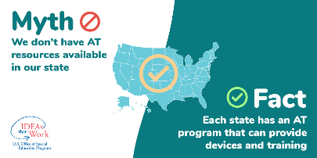 | Wide rectangular graphic. Myth: We don’t have AT resources available in our state. Fact: Each state has an AT program that can provide devices and training.

