Guide to Professional Learning for Accessibility and
Assistive Technologies
Professional Learning (PL) for educators as related to virtual learning opportunities has two components.
- Direct Student Support: PL should be offered on topics that maximize learning opportunities for all students. Often, educators have little background or experience teaching students with disabilities in virtual learning settings.
- Content Development: Many virtual programs choose to develop their own curriculum content. This requires the responsibility of providing training and support related to creating accessible content.
Consider the following questions and resources to develop professional learning programs that ensure accessibility and assistive technologies are fully utilized by students, educators, and families.
- Accessibility and Assistive Technologies in Virtual Settings
- Development of Accessible Content
- Additional Supports
- Opportunities to Connect with Others
- Resources

Accessibility and Assistive Technologies in Virtual Settings
Questions to Ask | Considerations/Resources | District/School Plan
Do educators know how and when to use features to support students with disabilities?  Are educators seeking additional support related to accessibility and assistive technologies in a virtual learning environment? | These resources, focused on teaching strategies in virtual learning environments, were developed by virtual schools prior to the pandemic.  eSchool Garnet Valley  - 6 Ways to Support Special Education Educators in Blended Learning Classes. Edutopia: By Sam Mormando, Director of Technology, Innovation, and Online Learning  North Carolina Virtual Public School (NCVPS)  - Webinars for Educators - Several free webinars are available in each of the following topics  - Accessibility and Copyright  - Communication  - Administration and Leadership  - Feedback  - Online Instruction  - Student Engagement  - Teaching Virtually - The Basics  - Tools and Technology  - Working within Your Course  - Workload Management
Are educators adept at using the accessibility features found in various devices, platforms, and software? | Embedded AT and Accessibility Features in Devices  - ChromeOS  - iPadOS  - iOS  - Windows 11  Learning Management Systems (LMS) and Accessibility  - Canvas Accessibility  - Blackboard Accessibility  - Google Classroom Accessibility  - Schoology Accessibility  Other Programs:  - Texthelp  - Read&Write for Google  - Microsoft Office Accessibility Suite

Development of Accessible Content
Questions to Ask | Considerations/Resources | District/School Plan
Are educators adept at developing accessible content? | These resources were developed by virtual school programs and national organizations devoted to the development of accessible content in virtual environments  - Mountain Heights Academy  - Open Education Resources  - CITES  - Provide Accessible Educational Materials  - Accessible Educational Materials Center (AEM)  - Designing for Accessibility with POUR  - Creating Accessible Documents  - Creating Accessible Video  - Protocol for Creating Accessible OER  - Quality Matters  - Address Accessibility Challenges with AURS  - Quality Matters provides a course review process

Additional Supports
Questions to Ask | Considerations/Resources | District/School Plan
If a student requires an assistive device, such as a single switch, what resources are available to support the student, family, and educators in the use and maintenance of the device? | - National Assistive Technology Act Technical Assistance and Training (AT3) Center  - Center for Parent Information and Resources
Do educators use strategies and technologies that support inclusion of students with disabilities in virtual environments? | - Literacy Instruction at a Distance: Strategies for Supporting Students with Learning Disabilities  This book has many strategies for teaching students with disabilities in virtual environments: Welby, K. A. (2021). Remote Learning Strategies for Students with IEPs: An Educator's Guidebook. Routledge.

Opportunities to Connect with Others
- AEM Cafe: Each month, CAST’s team of Technical Assistance Specialists host a one-hour discussion or share resources from the AEM Center as related to accessible educational materials.
- CITES Community of Practice: CITES Community of Practice (CoP) joins professionals interested in developing and sustaining inclusive technology and education systems as part of a cross-discipline, collaborative group.
- AT Town Hall: Sponsored by the Richard West Assistive Technology Advocacy Center, and the New Jersey Assistive Technology Act Project, this weekly virtual community of practice connects AT professionals from across the country and provides a forum for sharing ideas and discussion. Join every Monday at noon EST. For more information read their article: The Assistive Technology Services Experience of the 2020-2021 School Year, Jeff Sisk, Ed.S., Jennifer Carr, M.Ed., and Meaghan Tracy, M.Ed., Fairfax County Public Schools
- Quality Matters Accessibility and Usability Resource Site (AURS): Includes discussion boards integrated throughout.

Resources
- AEM Center Quality Indicators: The indicators offer guidance for leadership teams and practitioners on the components of coordinated systems that provide accessible materials and technologies for all learners who need them.
- Digital Learning Collaborative (DLC): The DLC provides resources, such as webinars, specific to online teaching and accessibility.
- National Standards for Quality: The standards provide a foundation for professional development related to virtual teaching, as well as developing accessible materials and courses for students with disabilities.
- NSQ Online Teaching Professional Learning Portal: Creates a framework for schools, districts, and state agencies to support online and hybrid instruction for every educator who needs such mastery. Professional development materials, based on the NSQ standards, are suggested once educators complete a self-evaluation.
- Quality Matters: Provides free and for-pay professional development opportunities for online learning, including resources dedicated to accessibility.
- Research and Reports from Members of the Virtual Learning Leadership Alliance: Tools, research, and reports developed by virtual schools across the country provide guidance for professional development and the inclusion of students with disabilities in virtual settings.
- Virtual Learning Leadership Alliance (VLLA): An association of virtual programs that provides resources, services, and expertise.
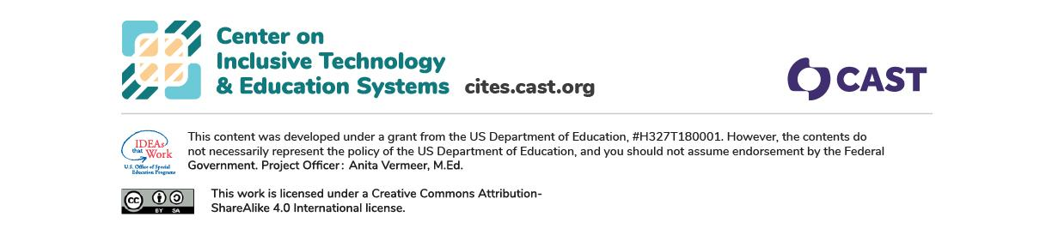
- Book: Welby, K. A. (2021). Remote Learning Strategies for Students with IEPs: An Educator's Guidebook. Routledge.

